Asian jumping worms -white band, 2 species

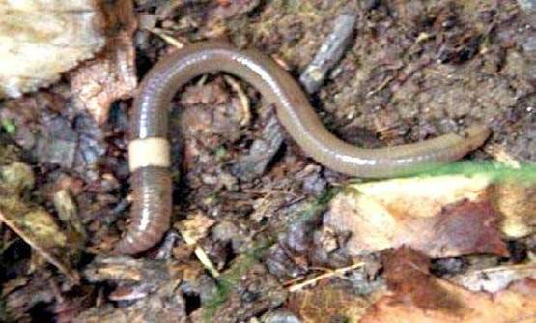

European earthworms – red band, many species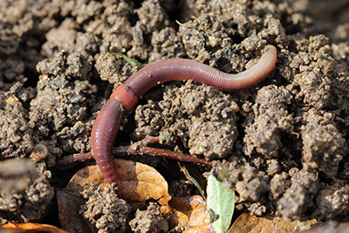

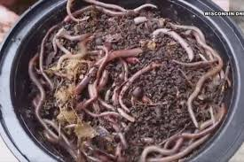
Asian jumping worms dug up from ground
Asian jumping worms, aka Alabama jumpers aka snake worms aka crazy worms:
- Arrived from Asia in late 1800’s in ballasts of ships in southeast USA.
- Grow up to 8 inches.
- Wriggle and jump aggressively when disturbed.
- Asian jumping worm invasions are hard to contain. Where most European worm species move about 30 feet per year, jumping worms can easily cover 17 acres, or roughly the size of 13 football fields, of new ground in a single season.
- Annual life cycle. The adults die in late fall, but leave tiny cocoons, difficult to spot, that overwinter.
- Survive to – 40 degrees F.
- Grow quickly in the spring, outcompeting and often eliminating other earthworms.
- Hermaphroditic, they can reproduce sexually, but also parthenogenetically, producing cocoons without fecundation, so it takes only one to start a new colony.
- There are two generations per year (three in mild climates).
- Grow up to 8 inches long.
- Jumping worms live in denser numbers than regular earthworms and thin the layer of forest litter (duff) at a speed unknown in other earthworm species, reducing it by 95% and leaving the soil essentially bare.
- The degradation of the litter is so rapid that the nutrients released cannot all be absorbed by the soil and plant roots.
- Jumping worms also consume plant seeds and rob the soil seed bank of its reserves.
- The resulting environmental degradation causes a loss of plant species.
- The relationship of trees and mycorrhizae is disrupted which results in diseased or dying trees.
- Native species, dependent on thick leaf litter are eliminated, mostly replaced by invasive exotic weeds.
- They are equally damaging in forest, prairie, commercial grower and home gardener environments.
- Animals are affected. Salamanders and many bird species will not eat jumping worms, spitting them out or avoiding them after an initial tasting. Ground-nesting birds disappear.
- Currently in 37 states, including Delaware and spreading rapidly. Currently no method to stop invasions.
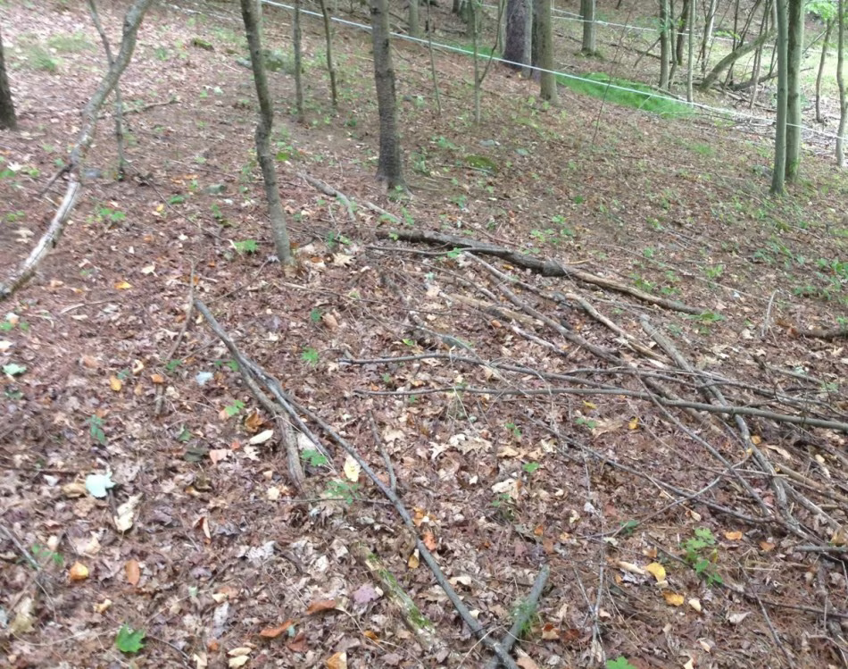Barren forest floor after invasion

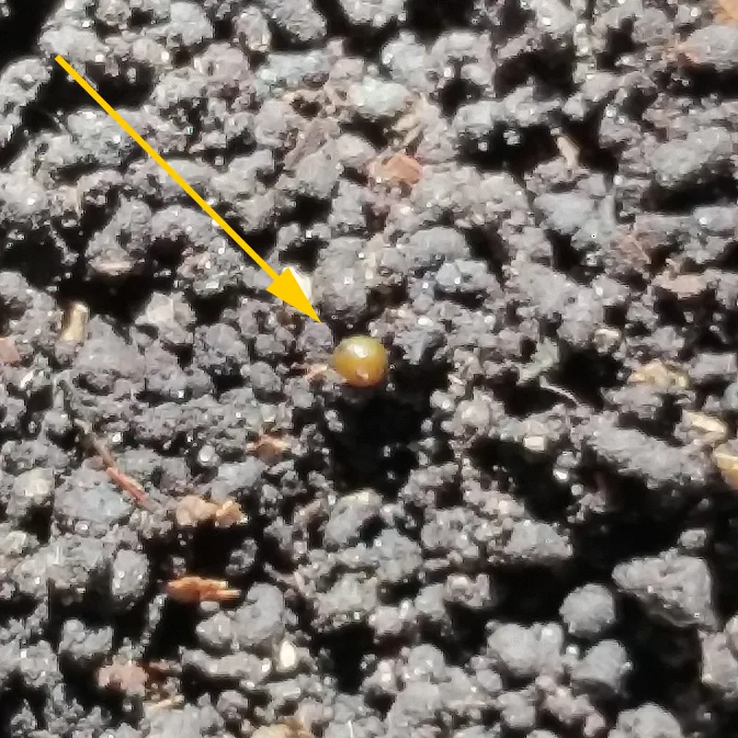
Asian jumping worm cocoon

What is being done:
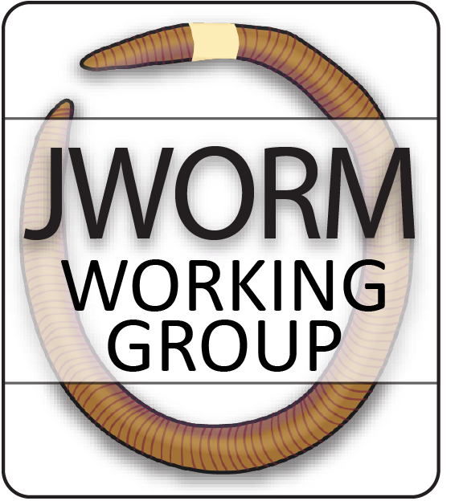
Jumping Worm Outreach, Research and Management Working Group
The group is working to raise awareness of the invasive jumping worm (Amynthas & Metaphire sp.) to homeowners, garden clubs, and the horticulture trade. Since there are no current effective control measures for jumping worms once established, the group emphasizes the need to prevent introductions. Creating checklists outlining preventative actions (cleaning garden tools, heating soil, etc.) to empower gardeners and other stakeholders to reduce their spread is one important initiative of the group.
The JWORM Working Group:
Annise Dobson, Postdoctoral Researcher, Yale University
Andrea Davalos, Assistant Professor, SUNY Cortland
Brad Herrick, Ecologist & Research Program Manager, UW Madison Arboretum
Timothy McCay, Professor, Colgate University
Kyle Wickings, Associate Professor, Cornell University
Carrie Brown-Lima, Director, NYISRI
Audrey Bowe, Project Coordinator, NYISRI
Do I have jumping worms?
Test your yard:
- Clear an area of ground.
- Mix one gallon of water with 1/3 cup dried mustard.
- Slowly pour over the ground.
- If you have jumping worms they will shortly appear at the surface.
- Collect them, seal them up in a plastic bag and throw in the garbage.

STOP THE SPREAD!
Be a worm-wise buyer
- Do not buy or use jumping worms for bait, vermi-composting, or gardening.
- Purchased earthworms may also be mislabeled, so learn to identify jumping worms by their look and behavior.
- Scout the Soil: Check new soil, compost, and mulch for jumping worms and inquire with providers if measures have been taken to reduce the spread of jumping worms.
- Use mulch, soil and compost that are free of jumping worms and cocoons. If you can’t confirm the source is jumping worm-free, only purchase or trade mulch, compost, and soil that has been heated to appropriate temperatures and duration following protocols for reducing pathogens (104 - 130˚F for three days is sufficient).
- Scan the Plants: Check the soil and roots of potted plants and trees for jumping worms or castings before planting them in your yard.
- When the option exists, choose bare-root plants over potted plants, ensuring no soil remains affixed. If you find jumping worms in materials you bring in, dispose of all contaminated soil and castings in the trash and kill worms by freezing or leaving in a bag out in the sun, then discard.
Take initiative
- Check your property periodically for jumping worms.
- Report jumping worm observations to DNREC and Sussex County Extension Agent.
Clean boots, gear, and even roots
- Clean compost, soil and debris from vehicles, personal gear (clothing and boot treads), equipment, and gardening tools before moving to and from sites. Anything larger than a poppy seed could contain jumping worm cocoons.
- When working with logging and landscaping companies, request that equipment arrive and leave clear of soil– and encourage your neighbors and local government to do the same.
- If jumping worms are present on your property, minimize the sharing and moving of plants where possible.
- If you do move or share plants, wash roots and share them either bare-root or re-pot in sterile potting soil.
- When sharing or moving seedlings and small plants, rinse roots to minimize jumping worm spread when possible: gently massage roots in a basin of water to remove soil clumps, until no soil remains affixed. Afterwards, strain the water and place any solids larger than a poppy seed in a trash bag in the sun before disposing.
Link to the JWORM checklist for home gardeners:
www.nyisri.org/research/jworm-2/

