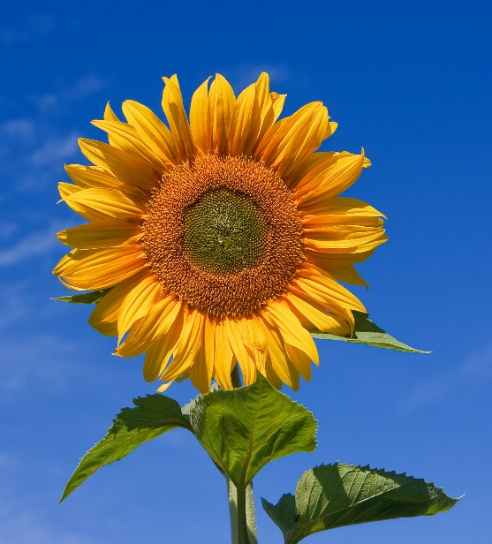
Gardeners By the Sea
September Horticulture Challenge
The Sunflower Challenge
Hopefully many of you are going to plant sunflowers this year to show your support for the people of Ukraine. The September Horticulture Moment will be all about sunflowers!
Here is the challenge:
- Bring one of your sunflowers to the meeting
- Wear something with sunflowers on it to the meeting
- Bring a photo of sunflowers to the meeting
- Make a floral arrangement that highlights sunflowers to the meeting

