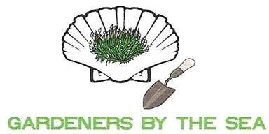

MEETING AGENDA
May 13, 2022
Evans Park Community Center

Call to Order and Welcome: Anne McKinney, Vice-President
- Welcome Guests & Birthdays: Karen Plis, Membership

Minutes: Secretary – Laura Martin

Program: Ria Carraro – How to Make Floral Ice Bowls and Edible Apricot Roses

Report of Officers:
- President: Anne McKinney for Alva Hutchison
- Vice President: Anne McKinney
- Secretary: Laura Martin
- Treasurer: Carolyn Clipp for Mary Williford

Committee Reports:
- 30th Annual Beach & Bay Cottage Tour – Ria Carraro
- Awards - Donna Gray
- Coastal Cleanup – Thea Chandross
- Lord Baltimore Gardens – Thea Chandross
- Community Projects - Maryanne Green for Maureen Eisenhart
  - Evans Park Landscaping Project – Tree Planting Tuesday, May 24th
  - Earth Day at Evans Park – Friday, April 22
  - Coastal Towns Village – planting held on May 4
    - Chicken Festival – Saturday, May 21
- Garden Therapy: Ria Carraro for Margaret Woda
- Habitat for Humanity – Eileen Quigley
- Hospitality – Sallie Melvin
- Membership - Karen Plis
- Ways and Means - Brenda Wimperis for Ann Bendersky
  - PLANT SALE – June 10th - Brenda Wimperis
    - Food Trucks – Steve Zimmerman
    - Seed Bombs workshop to be scheduled

Horticulture Moment: Pat Drizd – Sunflowers and Challenge for September 2022

Announcements

Adjournment

